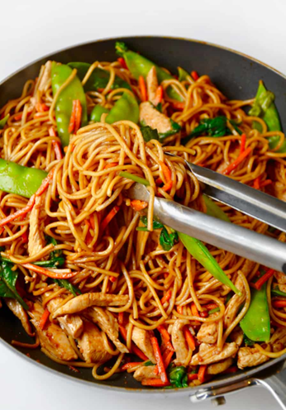Chicken Lo Mein

|  |
| --- |
| Ingredients With Measurements  * 1 lb chicken breast, sliced * 1 teaspoon pepper * 1 teaspoon salt * 2 teaspoon sesame oil, divided * ¼ cup chicken broth * 1 tablespoon soy sauce * 1 tablespoon hoisin sauce * 1 teaspoon cornstarch * 1 tablespoon vegetable oil * 2 cloves garlic, minced * 1 tablespoon minced fresh ginger * ½ cup shiitake mushroom, sliced * ½ cup onion, sliced * ½ cup carrot, sliced * ½ cup sugar snap peas, halved * 4 servings cooked egg noodles * 1 tablespoon green onions, chopped, for garnish |

|  |
| --- |
| Recipe In a medium bowl, season the chicken with pepper, salt and 1 tablespoon of sesame oil. Mix thoroughly and set aside.  In a separate medium bowl, combine the chicken broth, remaining tablespoon of sesame oil, soy sauce, hoisin sauce, and cornstarch. Mix thoroughly and set aside.  Heat the vegetable oil in a wok or large pan over medium-high heat. Add the chicken and cook until no longer pink inside, 3-4 minutes. Remove the chicken from the pan and set aside.  Add the garlic and ginger to the pan and cook until fragrant.  Add the mushrooms, onions, carrots, and sugar snap peas. Stir fry until the vegetables are tender.  Return the cooked chicken to the pan and add the cooked egg noodles and reserved sauce. Cook for 3 minutes, until everything is well-coated in the sauce.  Serve garnished with green onions. |

|  |  |  |  |  |  |  |  |  |  |  |  |  |  |  |  |  |  |
| --- | --- | --- | --- | --- | --- | --- | --- | --- | --- | --- | --- | --- | --- | --- | --- | --- | --- |
| |  |  |  | | --- | --- | --- | | Chicken Breasts | Pepper | Salt | | Sesame Oil | Chicken Broth | Soy Sauce | | Hoisin Sauce | Cornstarch | Vegetable Oil | | Garlic | Ginger | Mushroom | | Onion | Carrot | Sugar Snap Peas | | Egg Noodles | Green Onion |  Ingredients Without Measurements |